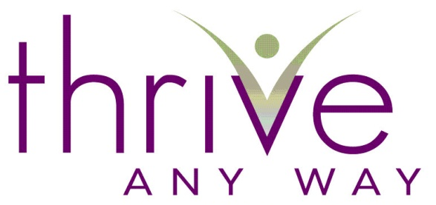

Part II
Creating 2023 Worksheet

Now that you’ve completed 2022, take some time to really consider what you want to create for 2023. Do so by choosing for you and only you. Not what you think you want or what someone else wants for you or what you want because it will look good.

Choose as if no one is looking and you get to create from nothing. Choose with reckless abandon. Allow yourself to be daring and unreasonable. Give yourself the gift of this exercise with full self-expression and allow yourself to unfold into each question.

There is nothing better that being the pilot of your life. Create, Create, Create!

- If you’d prefer to do this exercise with me click here for more information

Date Click here to enter text.

Creating 2023

- What are you committed to accomplishing this year in all areas of your life? (Include specific results as well as areas you would like to expand which are not necessarily measurable).

Click here to enter text.

- In order to produce the above, what do you think you need to develop in yourself?

Click here to enter text.

- Are there goals you would like to take on but don’t quite trust yourself to say you really will?

Click here to enter text.

- What are the relationships in your life that you want to create, develop or enhance?

Click here to enter text.

- Separate from your goals and accomplishments, are there areas you would like to begin to take on, to master, to learn about, etc…

Click here to enter text.

- What do you “know” about yourself that could, if not managed, stop you from accomplishing what you are setting out to accomplish?

Click here to enter text.

- What structure will you put in place to fulfill on all that you just wrote? Is there anyone in your life that you should give a copy of this to as a way of supporting yourself?

Click here to enter text.

- What is this year going to “be about” for you? (Example: A year of learning, a year of forgiveness, a year of peace, a year of prosperity, etc…)

Click here to enter text.

- Is there anything else you would like to create for the year 2023?

Click here to enter text.

Here’s to a FRANTASTIC 2023!
Enthusiastically,
Fran Asaro

If you are a mature woman interested in learning about becoming a YouTube Creator, check out SeniorTuber.com

Acknowledgement: I would like to thank my coach Thea Sommer of Beyond Ten Consulting and Business Services for providing me with this form that has helped me so much over the years and allowing me to pass it on to you.

