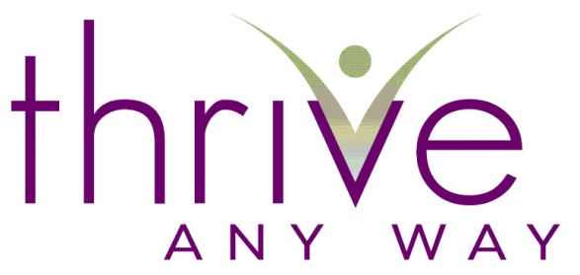

COMPLETING 2022 / CREATING 2023

Part I Completing 2022 Worksheet

A NEW YEAR, A NEW SLATE, A NEW YOU! CONNECT TO YOUR VISION!
Since it has become a tradition over time that we get a “do-over” at the beginning of each year, we might as well use that belief to our advantage. In completing these questions each year, we get to be more powerful, focused and directed than if you would just go with the flow. There is nothing wrong with the flow mind you; it’s a wonderful way to live. However, if you find that you are willing to write it out and manage it – You may increase your possibilities for success.

If we’ve worked together then you know our work is based on a belief that anything is possible when we stay connected to the vision. We design our actions to align with that vision. This way we begin producing results consistent with someone who is taking those actions.

To powerfully create, one must have a blank canvas. One of the accesses to that canvas is looking back at the past honestly and learning from it – taking the time to really acknowledge the successes and the failures – taking ownership and responsibility for the whole. This is not meant to be negative or ‘make-wrong’ experience. It is meant to clear any residue that remains so that we can create freely.

Feel free to do any or all of the exercises below. The more you do the clearer and more aligned and ahead of the game you will become. Do the best you can with what you know and be easy on yourself.

- If you’d prefer to do this exercise with me click here to contact me about meeting.

Preparation:

- Carve out time to do this process well and thoughtfully.
- Reference your calendars, promises & goals, to do lists and journals from the year.
- Give yourself a couple of days or weeks to continue to reference it so it is a work in progress.
- Run it by a couple of people who are close to you so you make sure you don’t miss anything.
- When you have done the work, set up a structure to look at these documents so you are managing it throughout the year.

Name Click here to enter text. Date Click here to enter text.

Completing 2022

- What are your accomplishments for the year 2022? (Include all areas of your life).

Click here to enter text.

- What did you learn about yourself in terms of what it took to accomplish what you did?

Click here to enter text.

- What are the areas of your life where you fell short, didn’t accomplish what you set out to, didn’t give 100% or missed the mark in terms of your goals or what you know you’re capable of producing? (Include all areas of your life).

Click here to enter text.

- What did you learn this past year about yourself in terms of #3 above?

Click here to enter text.

- What surprised you this year about yourself and/or others?

Click here to enter text.

- What are you proud of in terms of the year? Please include areas where you know you pushed through something or dealt with something that really required you to rise above what were predictable or what you thought was possible.

Click here to enter text.

- What are you disappointed with from the year? Where did you feel stopped or discouraged?

Click here to enter text.

- If you had the year to do over – which, of course, we don’t – what, if anything, would you have done differently?

Click here to enter text.

- Is there anything else you would like to say so that the year is complete for you?

Click here to enter text.

Here’s to a thorough completing of 2022 and a FRANTASTIC 2023!

Enthusiastically,
Fran Asaro

If you are a mature woman interested in learning about becoming a YouTube Creator, check out SeniorTuber.com

Acknowledgement: I would like to thank my coach Thea Sommer of Beyond Ten Consulting and Business Services for providing me with this form almost 20 years ago which helped me tremendously and allowed me to pass it on to you.

