5 Surprising Ways CBD Can Change Your Life!

by Robin Hoch

Research suggests that CBD-dominant cannabis from hemp, with a relatively low amount of THC provides the best combination for many wellness treatments. CBD does not provide the euphoric “high” found in THC. Our CBD products have zero THC and are legal in all 50 states, Canada, the United Kingdom, Ireland, and Sweden.

CBD-based ingestible supplements can reduce anxiety while CBD topicals have anti-inflammatory properties for pain reduction. The antioxidants found in CBD have anti-aging properties to refresh your skin. CBD can also work for insomnia.

For a growing number of us, cannabis is part of a healthy lifestyle. In moderation and in low doses, cannabis provides many wellness benefits. It’s not all about getting a buzz – it’s about a good night’s sleep, calming anxiety, relieving pain, improving your skin tone, or even treating your pets.

Here are just a few ways in which CBD-rich cannabis can help improve your life:

1. It Can Relieve Anxiety

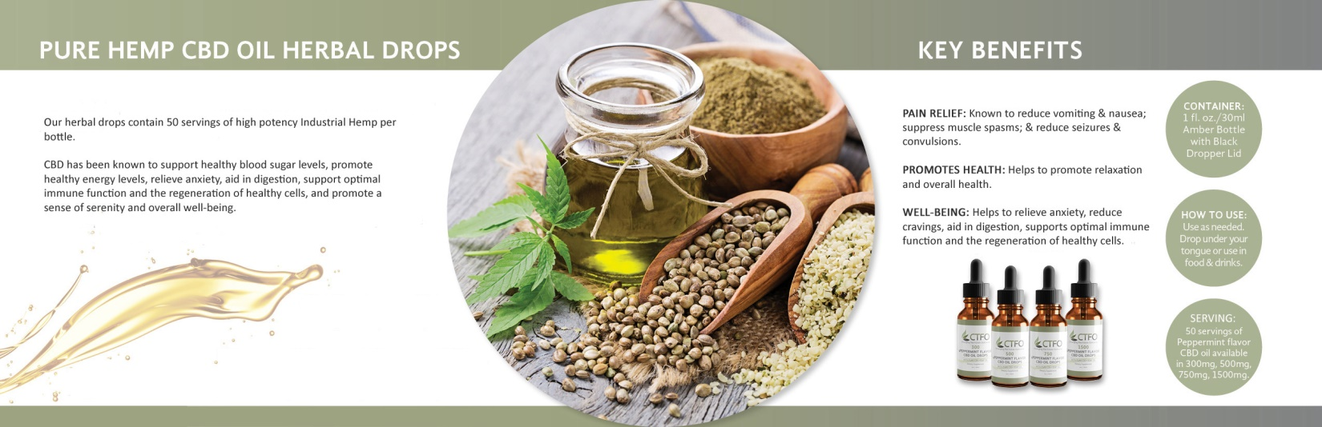

According to the Anxiety and Depression Association of America (ADAA), 40 million Americans – 18 percent of us – suffer from some kind of anxiety disorder. Studies suggest that cannabis contains anti-anxiety properties and benefits many people with issues related to anxiety disorders.

Anxiety is among the most common reasons cited for those seeking cannabis for medicinal purposes. Why? The idea of taking fewer pharmaceutical drugs is an attractive proposition for many people. In states with legal cannabis, patients use significantly less prescription medication. Knowing that cannabis can be an affordable and safe option makes it worth a try.
A 1999 study in The Journal of Clinical Psychiatry discovered a huge societal price tag for anxiety: Roughly one-third of America’s total mental health costs, $42 billion a year, goes to treating anxiety-related disorders.

CBD and Anxiety

If your anxiety is acting up or if you’re having trouble coping during a particularly stressful time, CBD oil may help!

2. It Can Refresh Your Skin

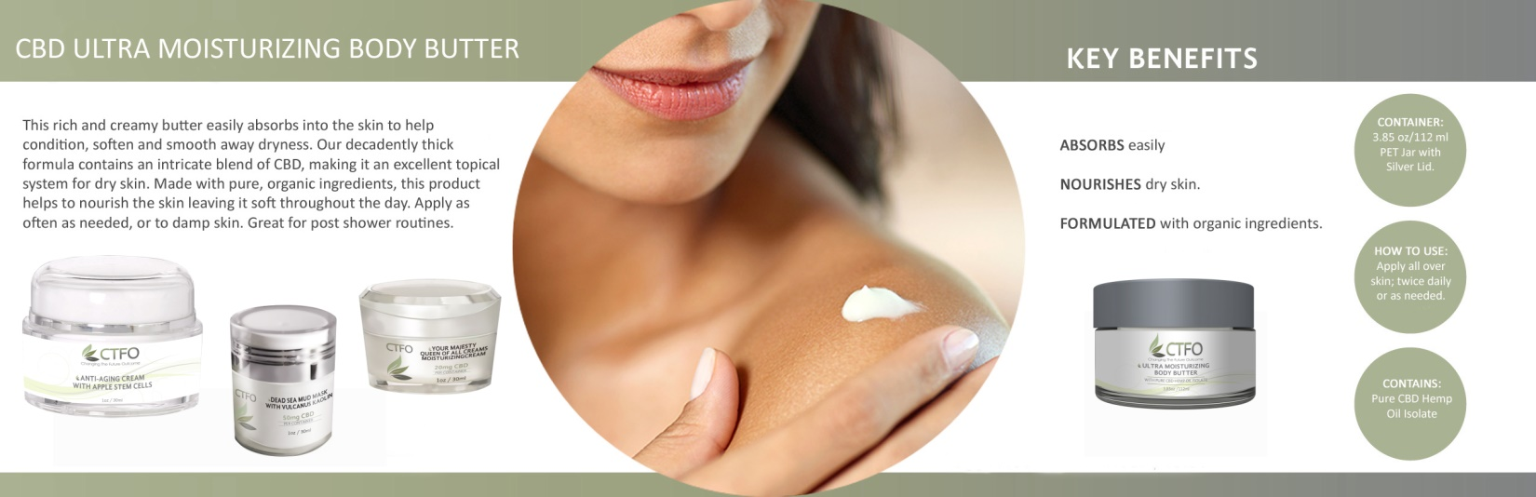

CBD is known to have anti-inflammatory properties and many cannabis companies are turning to CBD-dense topicals to help with inflammation. In fact, some researchers find that CBD may be a secret anti-aging ingredient that could add beneficial nutrients to your skin.

Inflammation is the root cause of a variety of skin ailments, from acne to acute irritation to rosacea. Because of CBD’s anti-inflammatory and antioxidant properties, applying it to your skin may reduce puffiness, swelling, and soreness. CBD oil is rich in fatty acids and it can improve hydration and minimize moisture loss. Studies suggest that CBD oil may even inhibit the growth of acne.

CBD binds to a special set of receptors in the skin known as TRPV1 receptors, where it can help feelings of heat, itch, and pain. This explains why it has a soothing effect on the skin. Just as other natural oils are used in skin care, the natural fatty acids and antioxidants make it a good choice for people with dry skin and eczema.

3. It Can Reduce Pain

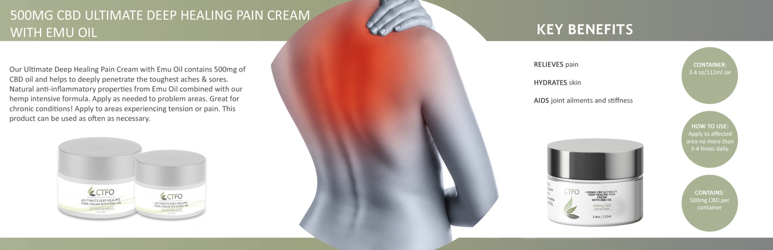

CBD may have real benefits for people living with chronic pain, Dr. Daniel Clauw, a professor of anesthesiology at the University of Michigan, recently told Health.com. Clauw cites a recent clinical trial that found that a CBD-derived topical drug provided pain relief to patients suffering from knee osteoarthritis.

Cannabis vs Opioids

“I don’t think we have that many good drugs for pain, and we know that CBD has fewer side effects than opioids or even nonsteroidal anti-inflammatory drugs, which can cause bleeding and cardiovascular problems,” Clauw told the medical website. “If I have an elderly patient with arthritis and a little bit of CBD can make their knees feel better, I’d prefer they take that than some other drugs.”

Studies reveal that CBD-rich cannabis can be as much as 20 times more effective than aspirin at reducing inflammation.

4. It Can Improve Your Sleep

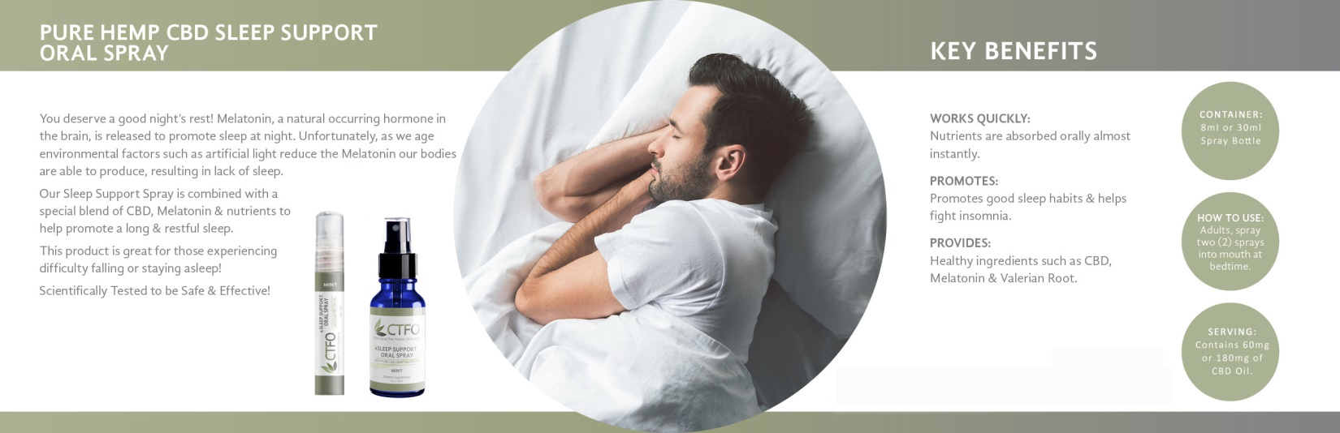
Research indicates that CBD has the ability to interact with serotonin receptors and GABA receptors in the brain. Serotonin plays an important role in mood and anxiety, and GABA is known as the main “inhibitory” neurotransmitter, meaning it calms excess activity in the brain and promotes relaxation.

CBD For Insomnia – Longer Sleep Time

According to a 2017 review of research surrounding the efficacy of CBD for insomnia, the substance has the potential to treat certain sleep disorders.

CBD has calming, anti-anxiety, and anti-psychotic effects. It may also provide a longer sleep time and reduce insomnia, according to research.

5. It Can Help Your Pets, Too!

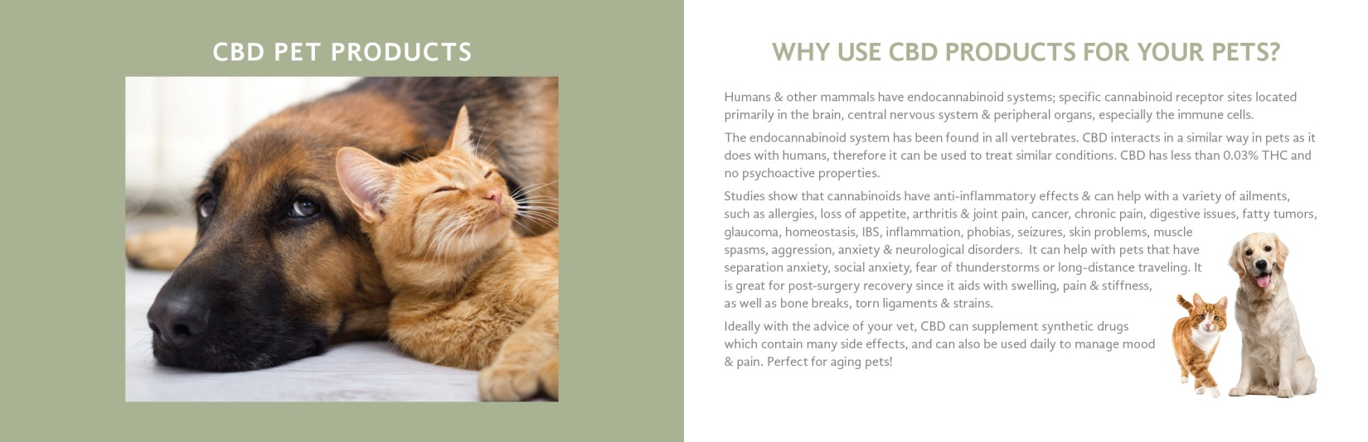

Cancer Pain

CBD products can help mitigate some cancer symptoms such as nausea, loss of appetite, or chronic pain.

Anti-Inflammatory

CBD interacts with receptors throughout the body and can act as an anti-inflammatory and immune-boosting agent.

Arthritis

CBD can alleviate these joint pains and have them moving around again.

Anxiety

CBD can help relieve the stress from separation anxiety, thunderstorms, fireworks, and noise phobias for many high-strung pets. It can also keep them calm while traveling.

Loss of appetite

CBD can boost appetite, reduce nausea, and alleviate digestive issues.

Seizures

CBD has been shown to reduce and help manage seizures brought on by epilepsy or other genetic disorders.

Aggressive behavior

CBD treats can help minimize aggressive behaviors and stress disorders.

BONUS #6 Way CBD Can Change Your Life: BUSINESS OPPORTUNITY!

Rolling Stone magazine predicts the CBD industry will hit 22 Billion dollars by the year 2022. It sounds cliché, but this really is a “ground-floor” opportunity! It’s a fairly new product that is in huge demand that can be potentially life-changing. There’s no better combination than that! As the knowledge and acceptance of medical marijuana increases, the demand for CBD will increase even further, because it offers the healing benefits without the “high.” And it’s available through companies like CTFO, at wholesale prices without a prescription, so it’s much more accessible to everyone who can benefit from it.

As a CTFO distributor, you’ll receive free websites to share and free training. You’ll be paid weekly and there’s no requirement to purchase anything or hit a quota. You’ll simply share the products and the opportunity and be paid handsomely for doing so. And it’s 100% FREE to join! You don’t even need to provide your social security or credit card number to enroll.

Go to http://robinhoch.com/cbdbiz now to learn more!

WHY IT WORKS

We have naturally occurring cannabinoid receptors throughout our bodies that interact with CBD. We have these receptors because our body is constantly making its own cannabinoids. These receptors and cannabinoids make up most of our endocannabinoid system (ECS). Our ECS is always in action, and if functioning properly, is a major factor in keeping us healthy. Many doctors now think that some people suffer from an endocannabinoid imbalance, known as Clinical Endocannabinoid Deficiency (CED). People suffering from CED may benefit from supplementing with cannabinoids, such as CBD.

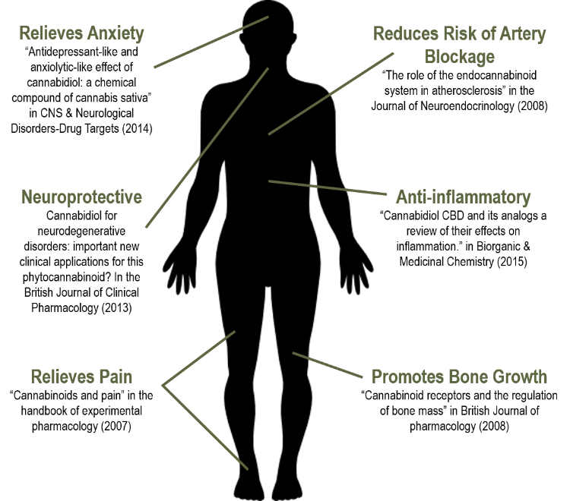

Go to http://robinhoch.com/cbd to learn more!

